Steps to create React App using CRA(CREATE REACT APP)
- Execute the following command to create a react application
npx create-react-app < YOUR_APPLICATION_NAME >
- Press enter and wait for the configuration installation to complete for the application
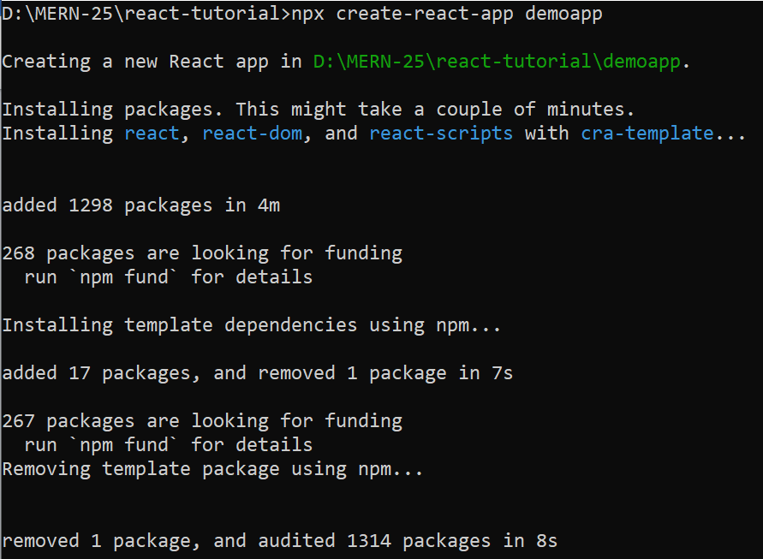
- After successful installation use following commands to test the project
Cd YOUR_APPLICATION_NAME
npm start
